**FATAL POLICE SHOOTING IN THE UNITED STATES**

Varsha Disawal

University of South Florida

ISM 6419: Data Visualization Final Project Report

Professor Han Reichgelt

Nov 10, 2023

**Introduction**

The issue of fatal police shootings in the United States stands as a profound and contentious facet of contemporary society, sparking intense debates about justice, accountability, and the relationship between law enforcement and the communities they serve. The occurrence of fatal police shootings has garnered widespread attention, shedding light on the complex intersection of race, socio-economic factors, and the use of force by those entrusted with maintaining public safety.

In recent years, high-profile cases and the advent of social media have propelled the matter into the forefront of public consciousness, prompting calls for reform and a reevaluation of policing practices. As communities grapple with the aftermath of these incidents, questions surrounding the justification for the use of lethal force, the role of implicit biases, and the adequacy of existing accountability measures have become focal points in the national discourse.

This discussion delves into the multifaceted dimensions of fatal police shootings in the United States, exploring the underlying factors, the societal impact, and the efforts being made to address and mitigate these tragedies. To comprehensively understand this complex issue, it is essential to analyze the historical context, legislative responses, and ongoing efforts to bridge the divide between law enforcement agencies and the various neighborhoods they serve. As the nation navigates these challenging waters, the imperative to strike a balance between public safety and the protection of individual rights remains a crucial task, demanding a thoughtful and informed examination of the root causes and potential solutions surrounding fatal police shootings in the United States.

In the United States, police officers are not required to report fatal shootings that happen on duty. Therefore, this Visualization records and analyses every fatal police shooting that happened between 2015 and 2022, answering on my research questions such as below listed as

* Police Shootings per State
* Police Shootings by their Race/Ethnicity and Age.
* Who are the victims of police shootings most?
* How many were carrying a gun?
* Check which region has many Police shootings.

**Ambitiousness**

Studying fatal police shootings in America is a highly ambitious undertaking due to the complexities and sensitivities surrounding the issue. Police use of deadly force is one of the most controversial topics in our society, involving heated debates around racism, police accountability, and public safety. A comprehensive examination of this subject requires gathering data from thousands of individual police departments across 50 states over many years. Each shooting represents a unique situation influenced by multiple factors, such as the details of the encounter, the backgrounds of the officers and civilians involved, department policies and training, and local laws. To fully understand the patterns and root causes behind fatal police violence, researchers must carefully analyze each incident within its full context while seeking to eliminate biases in how the information is collected and presented. They must also account for vast differences in environments ranging from major cities to rural counties. Meeting scientific standards for sample sizes and consistency poses challenges when compiling nationwide statistics on police shootings, which any centralized agency does not officially track. An undertaking of this scope demands substantial funding, labor, and time. Most importantly, the research must honor the lost lives and acknowledge deep societal trauma while providing insights that support positive reforms. Exploring this painful subject intensely begins an ambitious journey toward truth, justice, and community healing.

**Data Collection**

Data for this report is gathered from various sources, including official police reports, independent databases such as The Washington Post's "Fatal Force" project, and media coverage.

Below are the data sources listed as -

* <https://www.washingtonpost.com/graphics/investigations/police-shootings-database/>
* <https://data.gov/>
* <https://www.census.gov/>
* <https://mappingpoliceviolence.org/>

**Data Source Representation in Tableau:**  
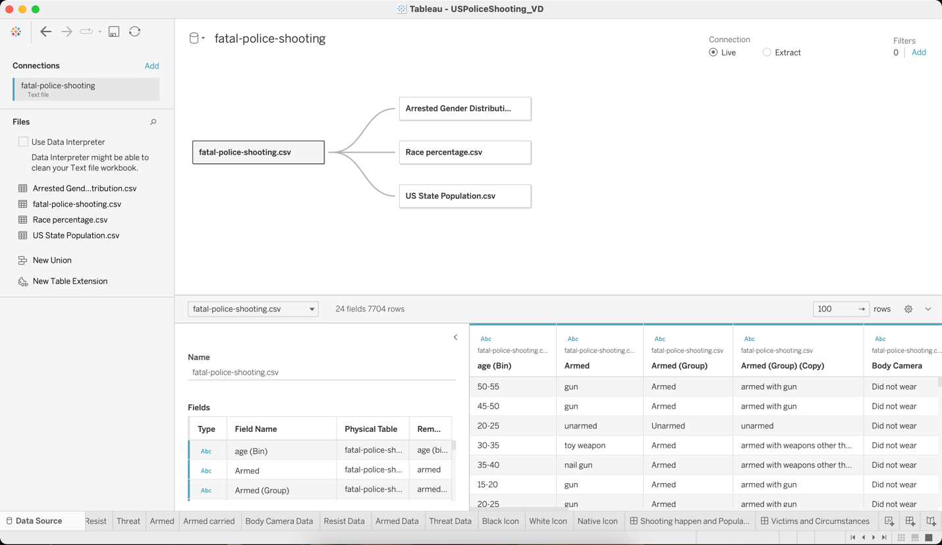

­Question been asked is who were shot and killed by the U.S. police?

**6,999 fatal police shootings were recorded between 2015 and 2022 would be an answer.**

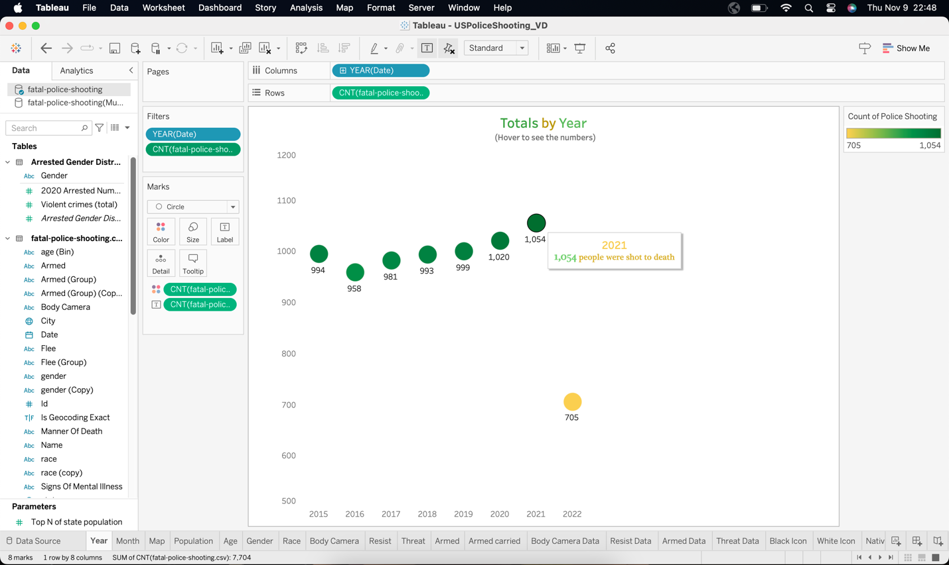

The number of fatal police shooting nationwide has increased gradually over the years. With an average of 1000 deaths per year, the chart peaks in 2021 which has a total of 1054 deaths.

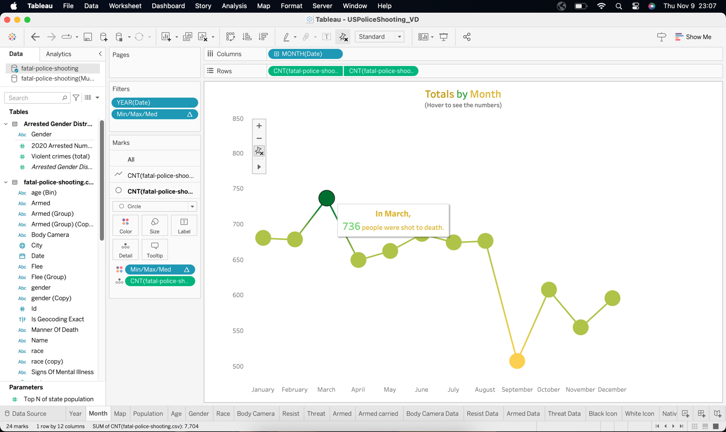

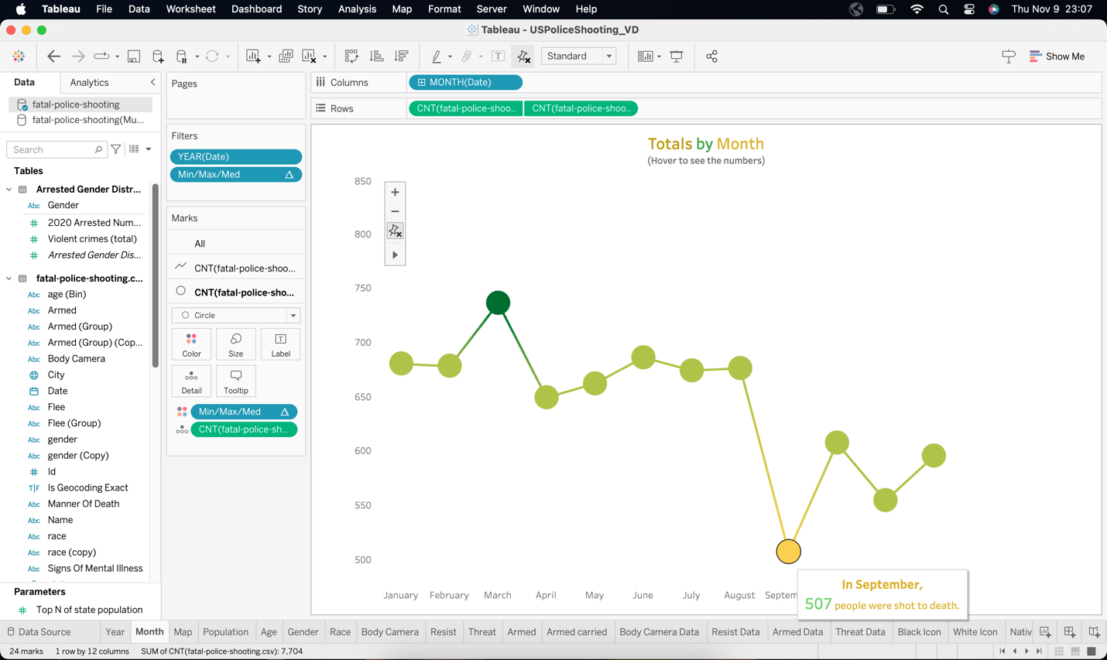

The monthly sum fluctuates between months. It peaks in March with a total of 736 deaths and hits bottom in September with a total of 507 deaths. There is a 23% difference between these two months.

The question is where did these shootings happen across the USA? **Answers would be given in the snapshots of the Tableau representations.**

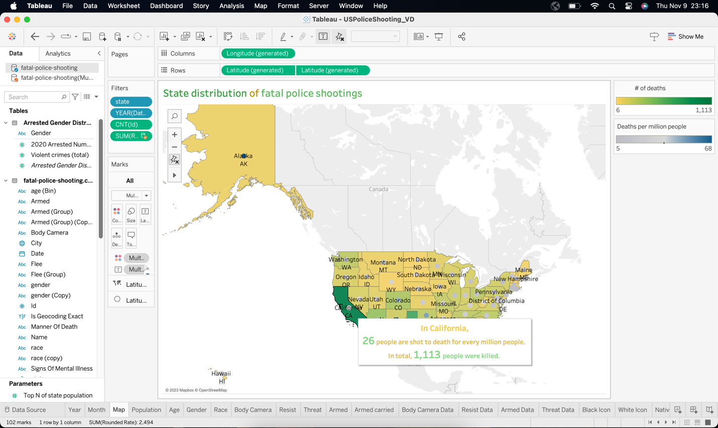

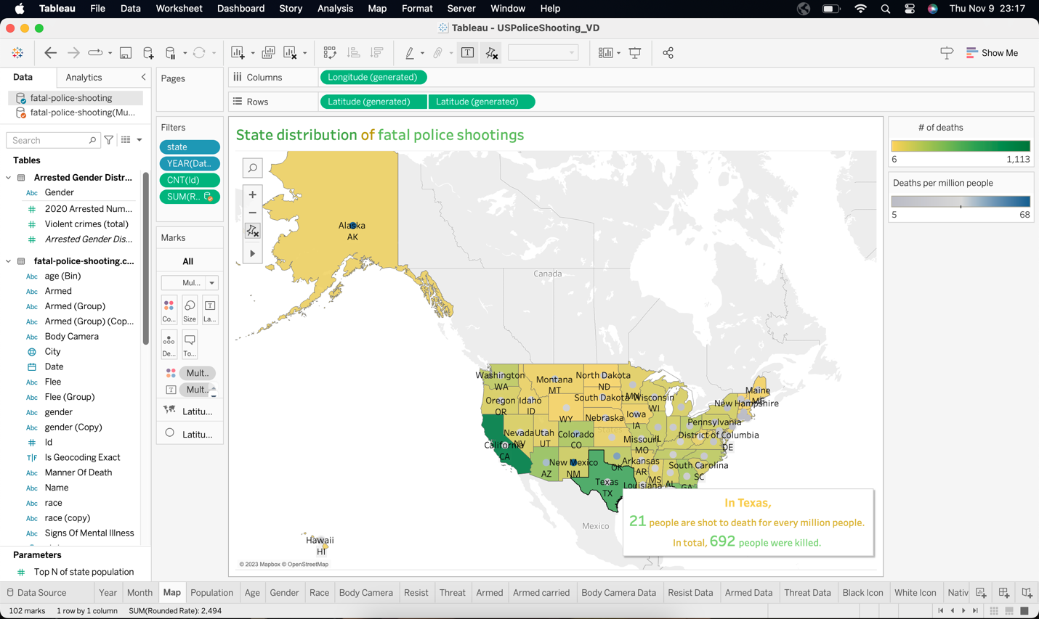

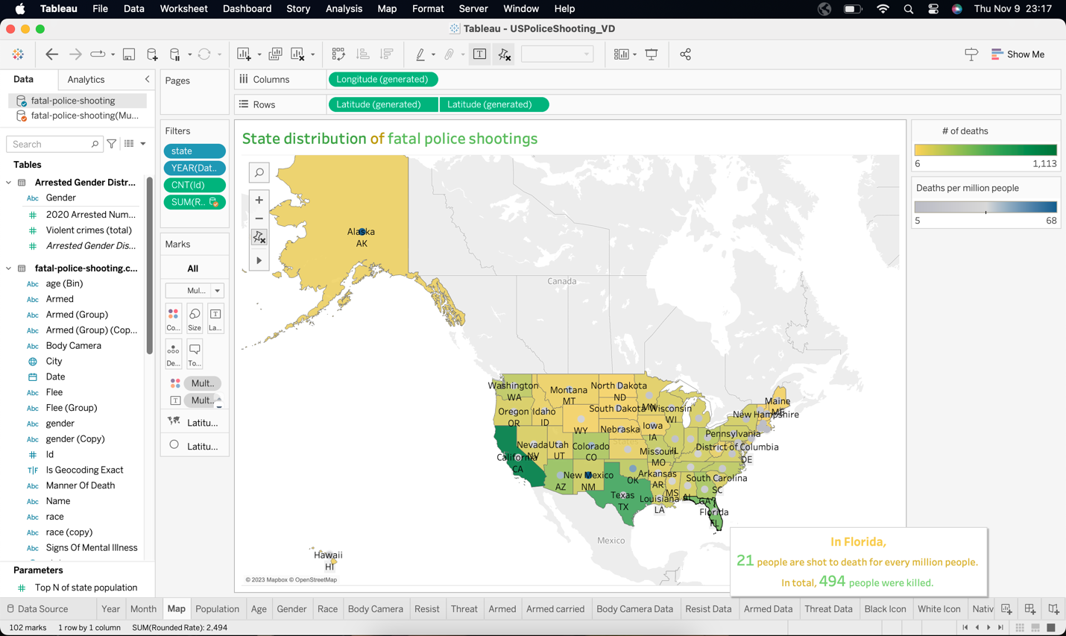

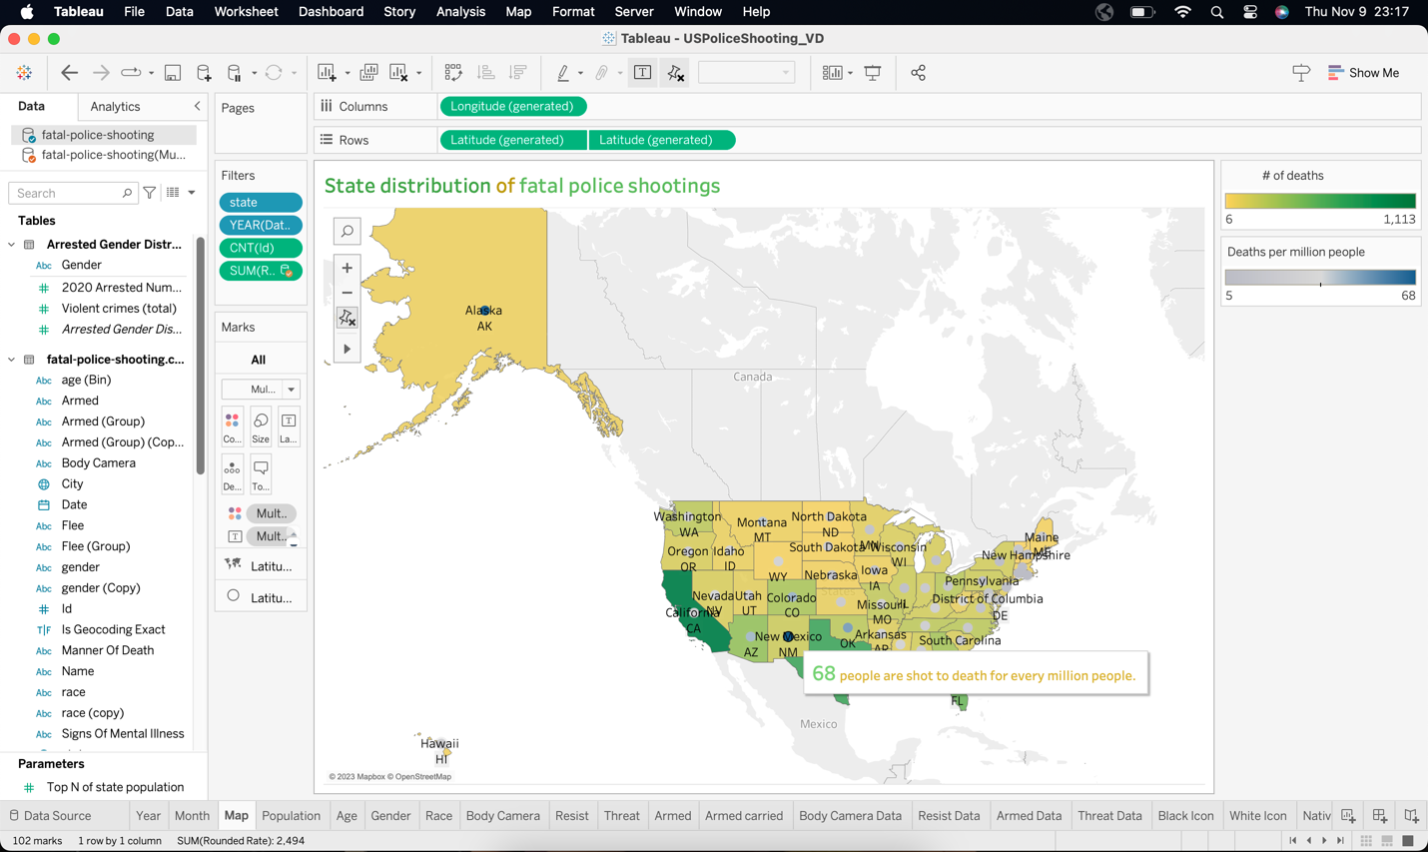

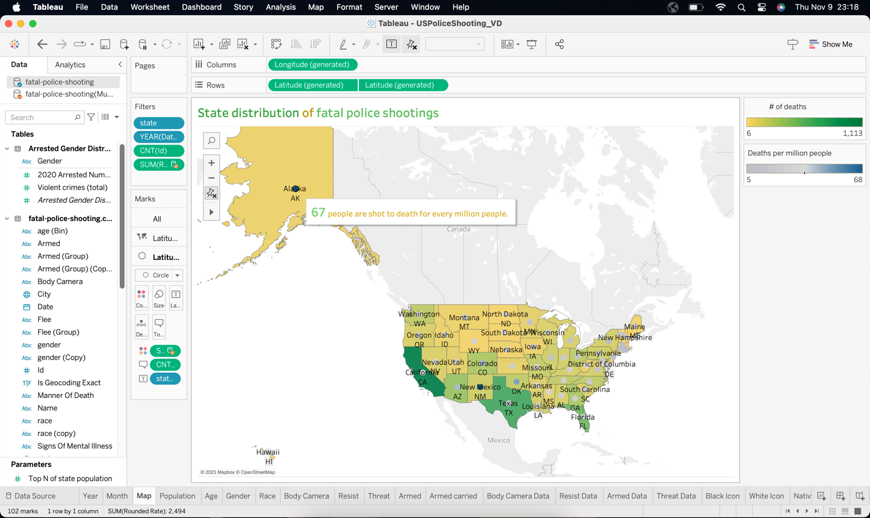

California, Texas, and Florida have the highest numbers of deaths, which are 1113, 692, and 494, respectively. It can be explained by populations as they are the top three states with the largest populations in the United States. Meanwhile, New Mexico and Alaska have the highest rates of deaths, which are respectively 68 and 67 people for every million.

**State Population:**

The United States is a vast and diverse country with a population that is distributed across 50 states and various territories. Population sizes vary significantly among states, ranging from densely populated areas to sparsely populated regions.

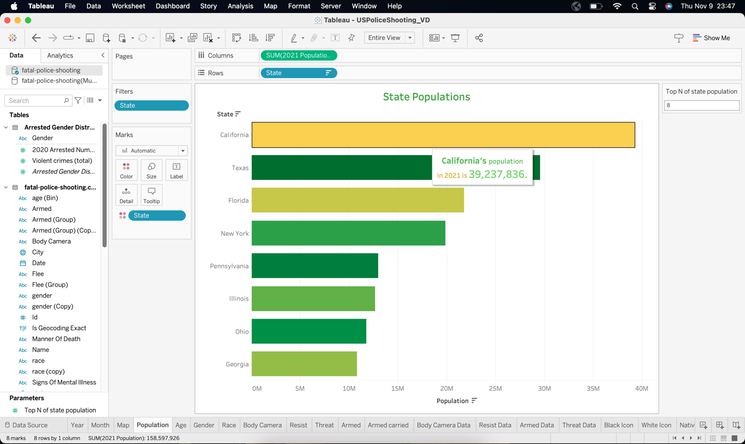

As of the last census conducted in 2022, the most populous state in the U.S. is California, home to over 39 million people. Texas and Florida follow closely as the second and third most populous states, with populations exceeding 29 million and 21 million, respectively. On the other end of the spectrum, states like Wyoming, Vermont, and Alaska have smaller populations, each with less than one million residents.

Population distribution is influenced by factors such as economic opportunities, climate, and historical development. Major metropolitan areas, like New York City, Los Angeles, and Chicago, attract large populations, contributing significantly to the overall state populations. Conversely, some states with vast rural areas may have smaller overall populations.

It's important to note that population figures can change over time due to factors such as migration, birth rates, and other demographic shifts. For the most current and accurate population data, it is recommended to refer to the latest census or demographic surveys conducted by relevant authorities.

Here I have used a parameter to check the Top N of State Population.

**Age Distribution:**

The analysis of fatal police shootings in the United States reveals a disconcerting trend, with the age group of 30 to 35 years old emerging as the most disproportionately affected demographic. This cohort comprises a substantial 16.87% of total victims, raising questions about the factors contributing to the heightened risk for individuals within this age range. Understanding the nuances of this statistic is critical for policymakers, law enforcement agencies, and the public.

This age group's prominence in fatal police shootings prompts a closer examination of the circumstances surrounding these incidents. Factors such as the nature of police encounters, potential escalation, and the prevalence of certain risk factors within this demographic warrant careful consideration. It is crucial to delve into the specifics of each case to discern commonalities and patterns that may shed light on the root causes of fatal outcomes.

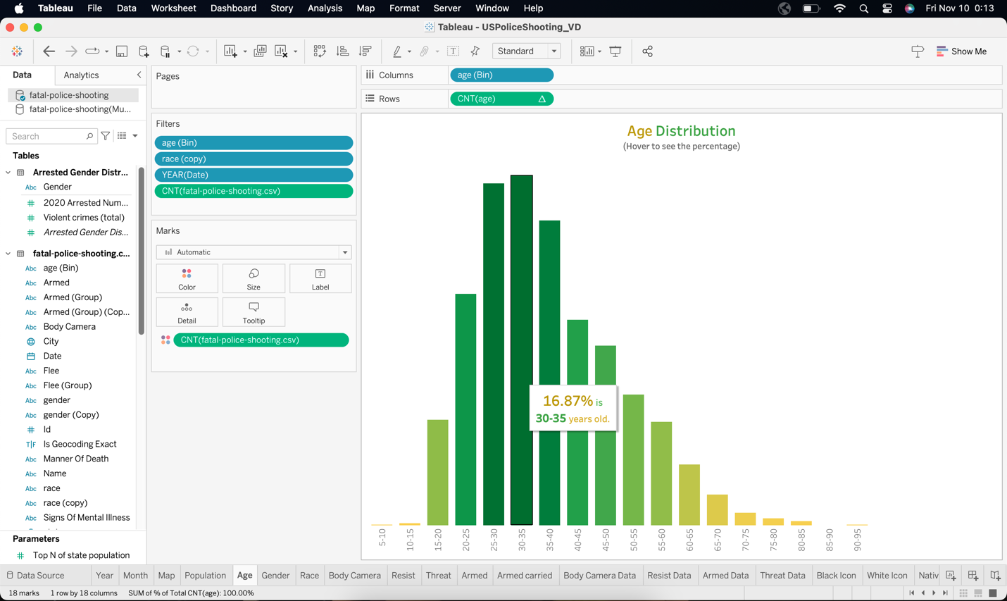

One potential avenue for exploration is the intersection of age and societal stressors. Individuals in their thirties often navigate significant life transitions, including career changes, family responsibilities, and financial pressures. Understanding how these stressors may interact with law enforcement interactions is vital for comprehending the heightened vulnerability of this age group. Police encounters during traffic stops, domestic incidents, or mental health crises may unfold differently for individuals in their thirties, necessitating tailored approaches in training and response protocols.

Moreover, the correlation between the 30-35 age group and fatal police shootings raises questions about the effectiveness of crisis intervention and de-escalation techniques employed by law enforcement. Are officers adequately trained to handle situations involving individuals in this age range, especially those facing mental health challenges or exhibiting erratic behavior? The data suggests an imperative need to reassess and enhance training programs, ensuring that officers are supplied with the skills to navigate diverse scenarios without resorting to lethal force, particularly when engaging with individuals in their thirties.

Examining the racial and gender dynamics within this age group can also provide valuable insights. Are specific racial or ethnic communities overrepresented within the 30-35 age range of fatal police shooting victims? Does gender play a role in the nature and outcome of police encounters for individuals in this demographic? Understanding these intersections is essential for addressing potential disparities and tailoring interventions that promote equitable treatment and products.

So, the revelation that the age group of 30 to 35 years old constitutes the highest percentage of victims in fatal police shootings in the United States demands a comprehensive and multi-faceted exploration. Policymakers, law enforcement agencies, and communities must collaborate to dissect the underlying factors contributing to this concerning trend. By fostering an evidence-based understanding of the dynamics surrounding fatal police shootings within this age group, society can work towards implementing targeted reforms in training, crisis intervention, and community engagement. Ultimately, the goal is to reduce the incidence of fatal outcomes, enhance public safety, and rebuild confidence between law enforcement and the neighborhoods they serve.

**Gender Distribution:**

The analysis of gender distribution in fatal police shootings in the United States unveils a complex and nuanced landscape. Here I have used a Diverging bar chart that perfectly shows Gender Distribution. While law enforcement encounters resulting in fatalities impact both men and women, the data underscores distinctive patterns that merit careful consideration. Understanding these gender dynamics is essential for shaping informed policies, fostering transparency, and addressing potential disparities within law enforcement practices.

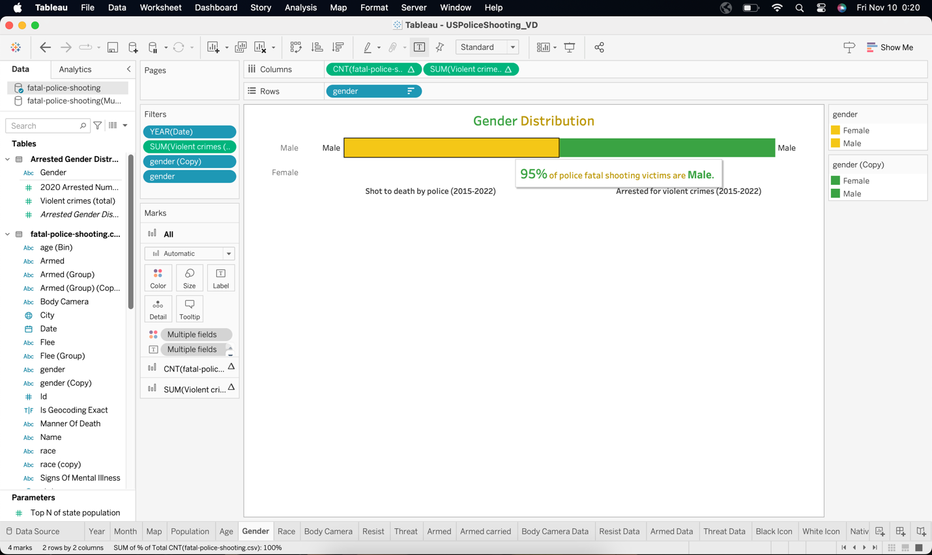

As of the latest available data, men constitute a significant majority of victims in fatal police shootings. The reasons for this imbalance are multifaceted and may stem from societal, cultural, and situational factors. Men, particularly those in specific age groups, may be more likely to find themselves in situations that escalate to encounters with law enforcement, such as traffic stops, criminal investigations, or domestic incidents. This higher prevalence of interactions could contribute to the elevated number of male fatalities.

However, it is crucial to delve deeper into the intersections of gender with other demographic factors, such as race and age. The data may reveal disproportionate impacts on specific communities, emphasizing the need for a more targeted and nuanced approach to addressing disparities. Are there specific racial or ethnic groups where the gender distribution in fatal police shootings is more pronounced? Does the individuals' age play a role in shaping the outcomes? These questions are pivotal for identifying potential areas for reform and intervention.

Examining the circumstances surrounding fatal police shootings involving women is equally crucial. Are there recurring scenarios or types of incidents that lead to these outcomes? Understanding the contexts in which women are more likely to be concerned in fatal encounters with law enforcement is essential for tailoring training programs and policies to address specific risk factors.

Mental health considerations also warrant attention in the gender distribution analysis. Research indicates that individuals experiencing mental health crises may be at an increased risk of encountering law enforcement, and this vulnerability could be gender-specific. Tailoring crisis intervention training to address different genders' unique needs and challenges is essential for ensuring a more effective and compassionate response.

Furthermore, the role of implicit biases and stereotypes must be acknowledged in discussions surrounding gender distribution in fatal police shootings. Unconscious biases may influence how law enforcement officers perceive and respond to individuals based on gender, potentially impacting the outcomes of police encounters. Addressing these biases through enhanced training and awareness initiatives can improve fairer and more equitable interactions.

Here, the gender distribution in fatal police shootings in the United States is a multifaceted and dynamic issue that demands a comprehensive and nuanced analysis. While men comprise most victims, understanding the intersections with race, age, mental health, and biases is essential for crafting targeted interventions. Policymakers, law enforcement agencies, and communities must collaborate to implement evidence-based reforms that enhance the safety and well-being of all individuals during interactions with law enforcement, irrespective of gender. By fostering transparency and addressing disparities, society can move towards a more just and equitable criminal justice system.

**Race:**

Examining the victimization rates between racial groups in fatal police shootings in the United States reveals a stark and concerning disparity. The data underscores systemic issues that demand urgent attention and reform within law enforcement practices. Historically marginalized communities, mainly Black and Hispanic populations, experience disproportionately higher victimization rates compared to their white counterparts. This grim reality emphasizes the need for a comprehensive and targeted approach to address racial disparities in police encounters.

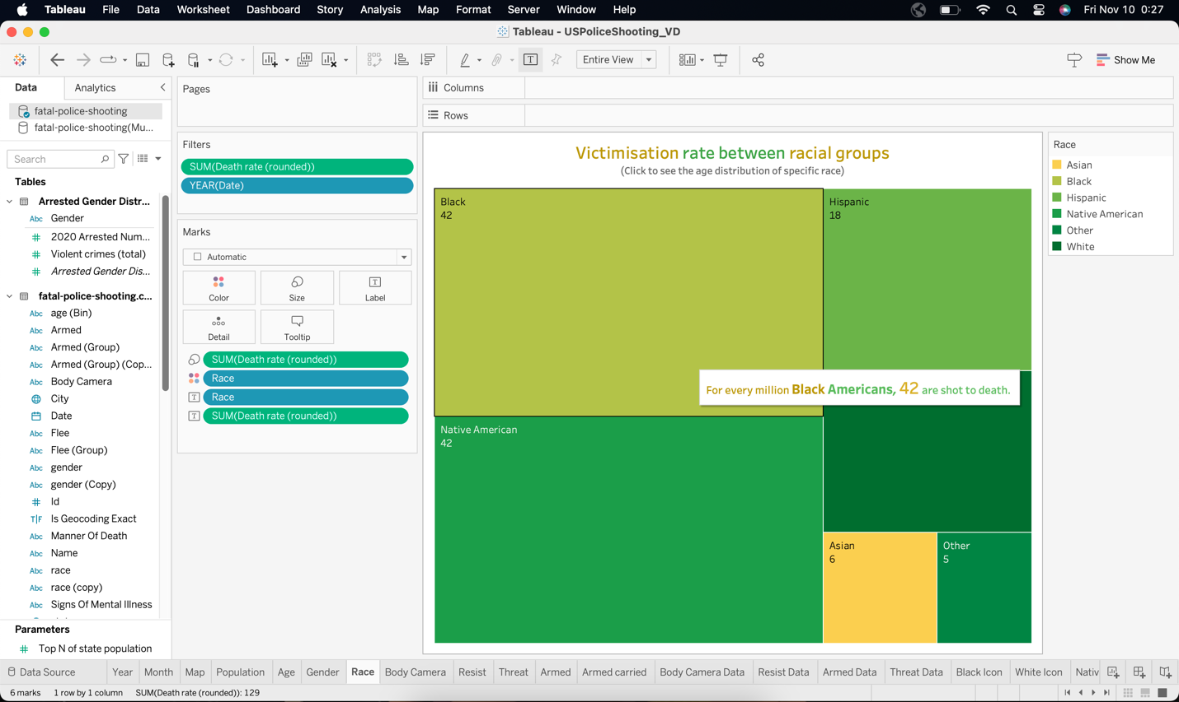

Black individuals face a significantly elevated risk of being fatally shot by the police. The reasons for this disparity are complex, involving a combination of historical injustices, socio-economic factors, and systemic biases. Efforts to address racial disparities in fatal police shootings must involve not only reforming law enforcement policies but also tackling broader societal issues such as systemic racism, poverty, and educational inequalities.

Initiatives to enhance community-police relations, implement de-escalation training, and promote transparency in policing practices are essential steps toward mitigating these disparities. Achieving lasting change requires a collective commitment to dismantling the roots of systemic racism and fostering an inclusive and equitable criminal justice system that ensures the safety and dignity of all citizens, regardless of their racial background.

**Use of Body Camera:**

The use of police body cameras in fatal police shootings in the United States represents a crucial step toward transparency, accountability, and the objective documentation of law enforcement interactions. These gadgets serve as a helpful tool in providing an unfiltered and impartial account of events, aiding in investigating and analyzing incidents involving lethal force.

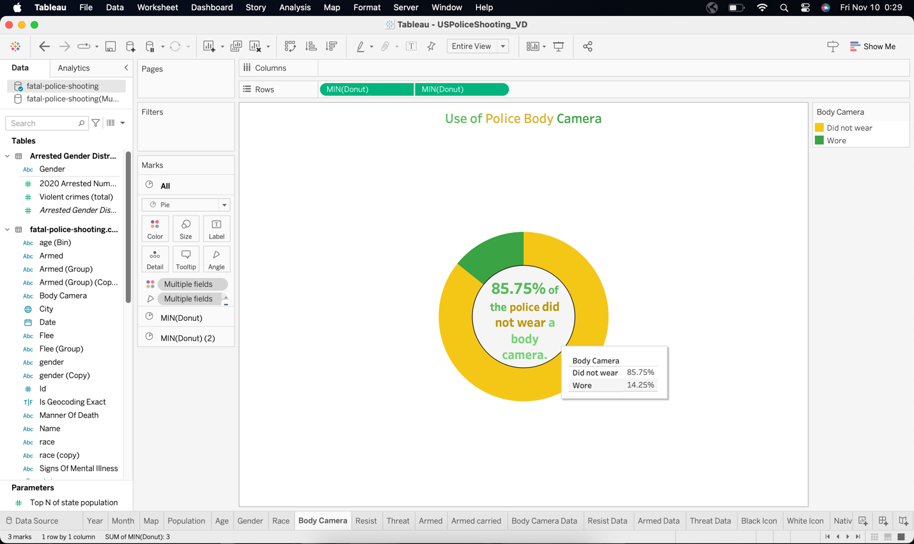

Body cameras offer a visual record that can significantly enhance incident reporting accuracy, enabling authorities to scrutinize the circumstances leading up to and during fatal encounters. The footage captured by these cameras not only holds law enforcement accountable for their actions but also provides a means of rebuilding trust within communities that have historically been affected by police violence.

Moreover, the presence of body cameras has been shown to influence the behavior of both officers and civilians during interactions. Knowing they are being recorded often encourages de-escalation and adherence to proper protocols, contributing to a safer and more accountable policing environment.

While using body cameras is a positive step forward, addressing challenges such as consistent implementation, privacy concerns, and access to footage is crucial. Policymakers must work to establish standardized guidelines for their use, ensuring that these devices fulfill their intended purpose of fostering accountability and transparency in the aftermath of fatal police shootings.

**Fleeing:**

Fleeing in fatal police shootings in the United States introduces a complex dynamic, often marked by a tense balance between public safety, law enforcement duties, and individual rights. Instances where individuals attempt to escape police custody can lead to heightened tensions and, tragically, the use of lethal force. Understanding the motivations behind fleeing, the response from law enforcement, and potential avenues for de-escalation is crucial for shaping effective policing practices.

Individuals may flee for various reasons, including fear of arrest, concerns about personal safety, or distrust of the criminal justice system. In such situations, police officers face the challenge of making split-second decisions while considering the potential threat posed by the fleeing individual. Training in de-escalation techniques, non-lethal force options, and strategies for apprehension without resorting to lethal measures is essential for minimizing the risk of fatal outcomes.

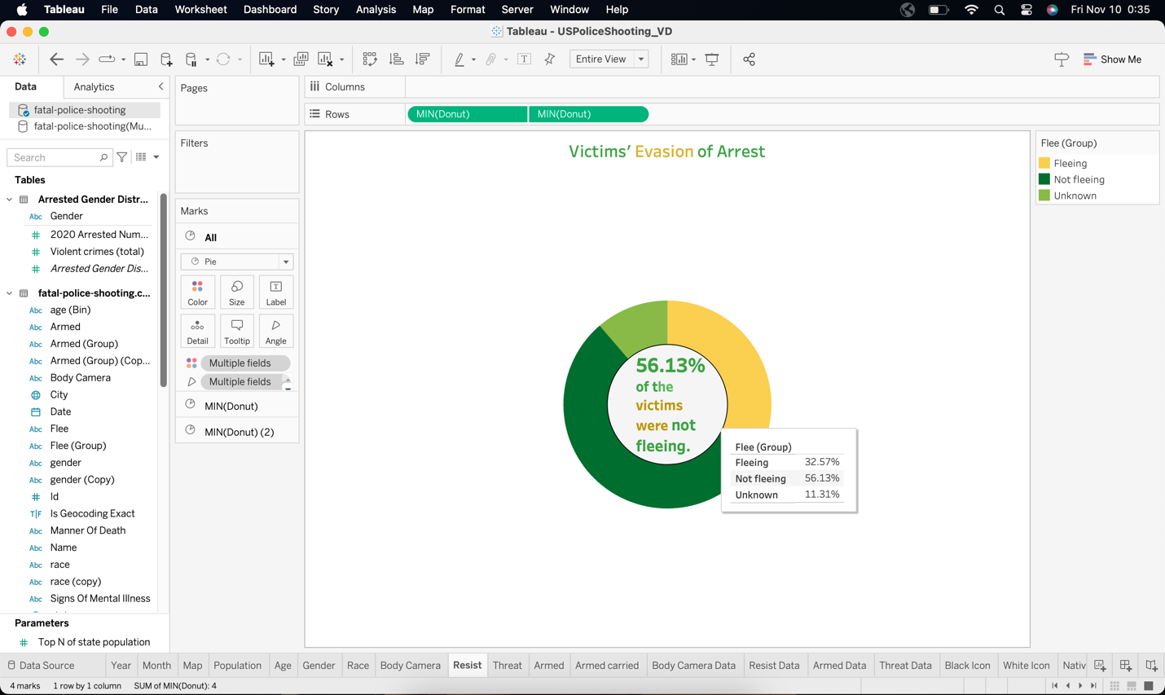

Moreover, addressing systemic issues such as poverty, limited access to education, and community-police relations can contribute to reducing the frequency of fleeing incidents. Investing in community outreach, social programs, and mental health support services can create an environment where individuals are less likely to feel the need to flee, fostering safer interactions between law enforcement and the public. Striking a balance between public safety and preserving life underscores the need for ongoing dialogue, reform, and collaboration to create a more just and equitable criminal justice system.

**Threat Level:**

The threat level plays a pivotal role in fatal police shootings in the United States, shaping the response of law enforcement officers in high-stakes situations. Understanding and accurately gauging the perceived threat posed by individuals is a complex task, and errors in judgment can lead to tragic outcomes. Police officers must navigate a delicate balance between ensuring their safety and the safety of the public while minimizing the use of lethal force. Factors contributing to the determination of threat level include as below.

* The presence of weapons
* The perceived intent of the individual
* The overall context of the encounter

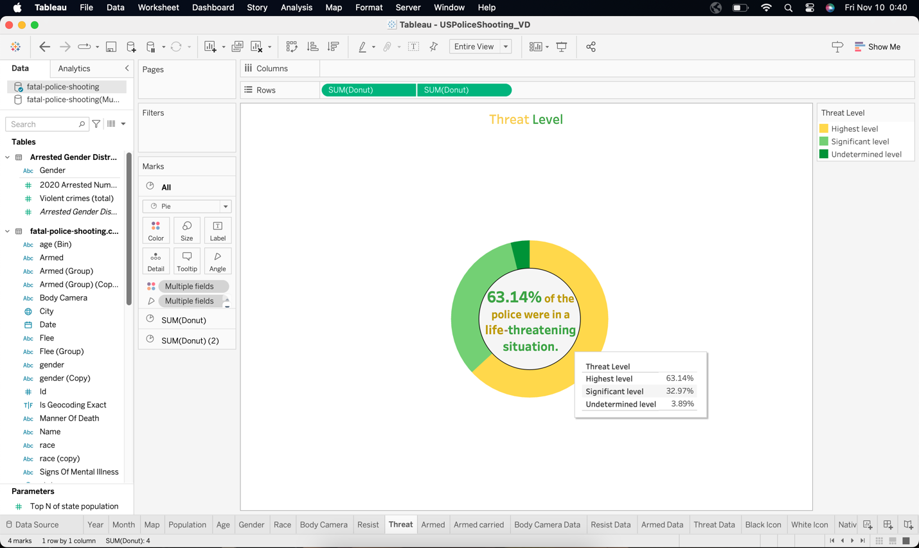

Individuals carrying firearms or exhibiting aggressive behavior may be perceived as posing a higher threat level, influencing the escalation of force by law enforcement.

Training programs emphasizing de-escalation techniques, crisis intervention, and conflict resolution are essential to enhance officers' ability to manage and mitigate potential threats without resorting to lethal force. Furthermore, improving communication skills and providing law enforcement agencies resources to address mental health crises can contribute to more effective threat assessment and response.

Transparency in reporting and investigating fatal police shootings, coupled with ongoing evaluations of law enforcement practices, is critical to maintaining public trust. Striking a balance between officer safety and preserving human life requires continual refinement of policies, procedures, and training to ensure a more equitable and just response to varying threat levels in police encounters.

**Armed:**

The presence of weapons in fatal police shootings in the United States introduces a critical factor that significantly influences the dynamics of law enforcement encounters. Incidents where individuals are armed often prompt heightened tension and decisions by officers that can lead to the use of lethal force. Assessing an individual's weapon possession, behavior, and context is pivotal in shaping the police response.

Law enforcement administrators are instructed to respond to potential threats to their safety and the public's safety, and the presence of a weapon elevates the perceived risk in any encounter. The split-second decision-making required in these situations underscores the importance of training programs emphasizing de-escalation tactics, conflict resolution, and using non-lethal force options.

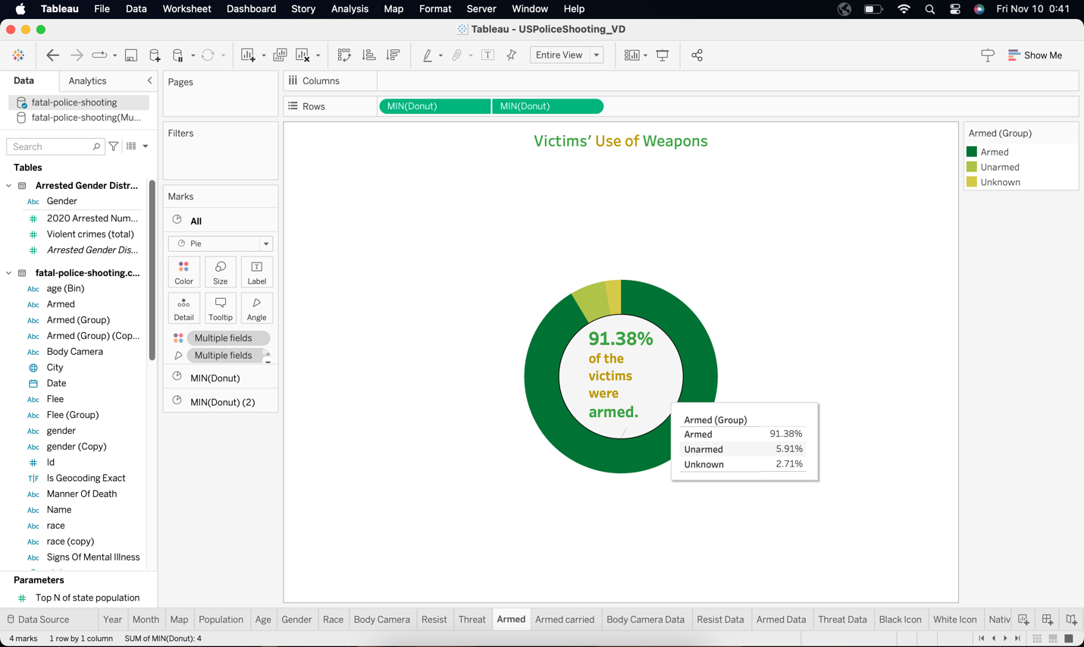

Addressing armed encounters should include community outreach and education, promoting responsible firearm ownership, and safe storage practices. Additionally, enhancing mental health crisis response strategies can contribute to a more comprehensive approach to situations involving armed individuals, as many such encounters may involve individuals experiencing emotional distress.

Hitting a proportion between guaranteeing officer safety and keeping the lives of individuals involved requires ongoing dialogue, evaluation of law enforcement procedures, and a commitment to implementing practices prioritizing de-escalation and using force only when necessary. Public trust is contingent on transparent reporting and thorough investigations that scrutinize the circumstances surrounding fatal police shootings involving armed individuals

**How many % were carrying Armed:**

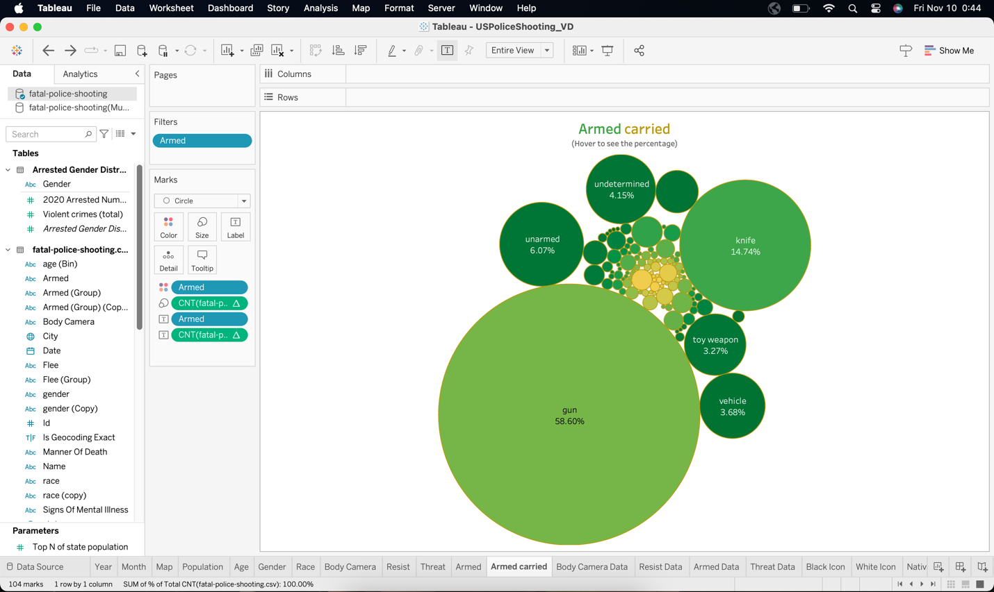

Analyzing the percentage of police officers armed in fatal police shootings in the United States provides crucial insights into the dynamics of law enforcement encounters we can see 58.60% carrying Gun and 14.74% carrying knife. Law enforcement personnel routinely carry firearms as part of their duty equipment, and the proportion of fatal incidents where officers use their weapons is a critical metric.

While most police interactions do not result in the use of lethal force, understanding the percentage of police officers armed during fatal encounters is essential for evaluating the overall risk and potential escalation in these situations. This statistic underscores the gravity of assessing the circumstances leading to officers resorting to their firearms, emphasizing the importance of training in de-escalation, conflict resolution, and non-lethal force options.

Tracking this percentage over time can contribute to informed discussions on law enforcement policies, training effectiveness, and the need for continuous improvement in ensuring the proper use of force. Transparency in reporting, coupled with thorough investigations into incidents involving armed police officers, is crucial for maintaining public trust and fostering accountability within law enforcement agencies. Ultimately, this statistic serves as a critical indicator for policymakers and communities to assess and refine policing practices, intending to minimize the occurrence of fatal incidents involving armed officers.

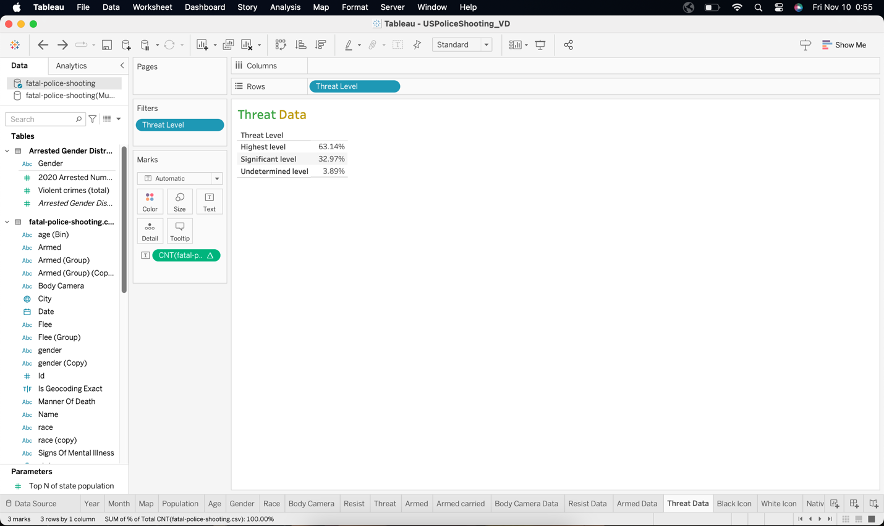

**Icons:**

Icons have been created for each Ethnic Group in the Tableau Sheet to identify the race.



I have used these icons by downloading a particular image from Google and saving it in Documents - My Tableau Repository and in that Shapes folder I have saved these icons.



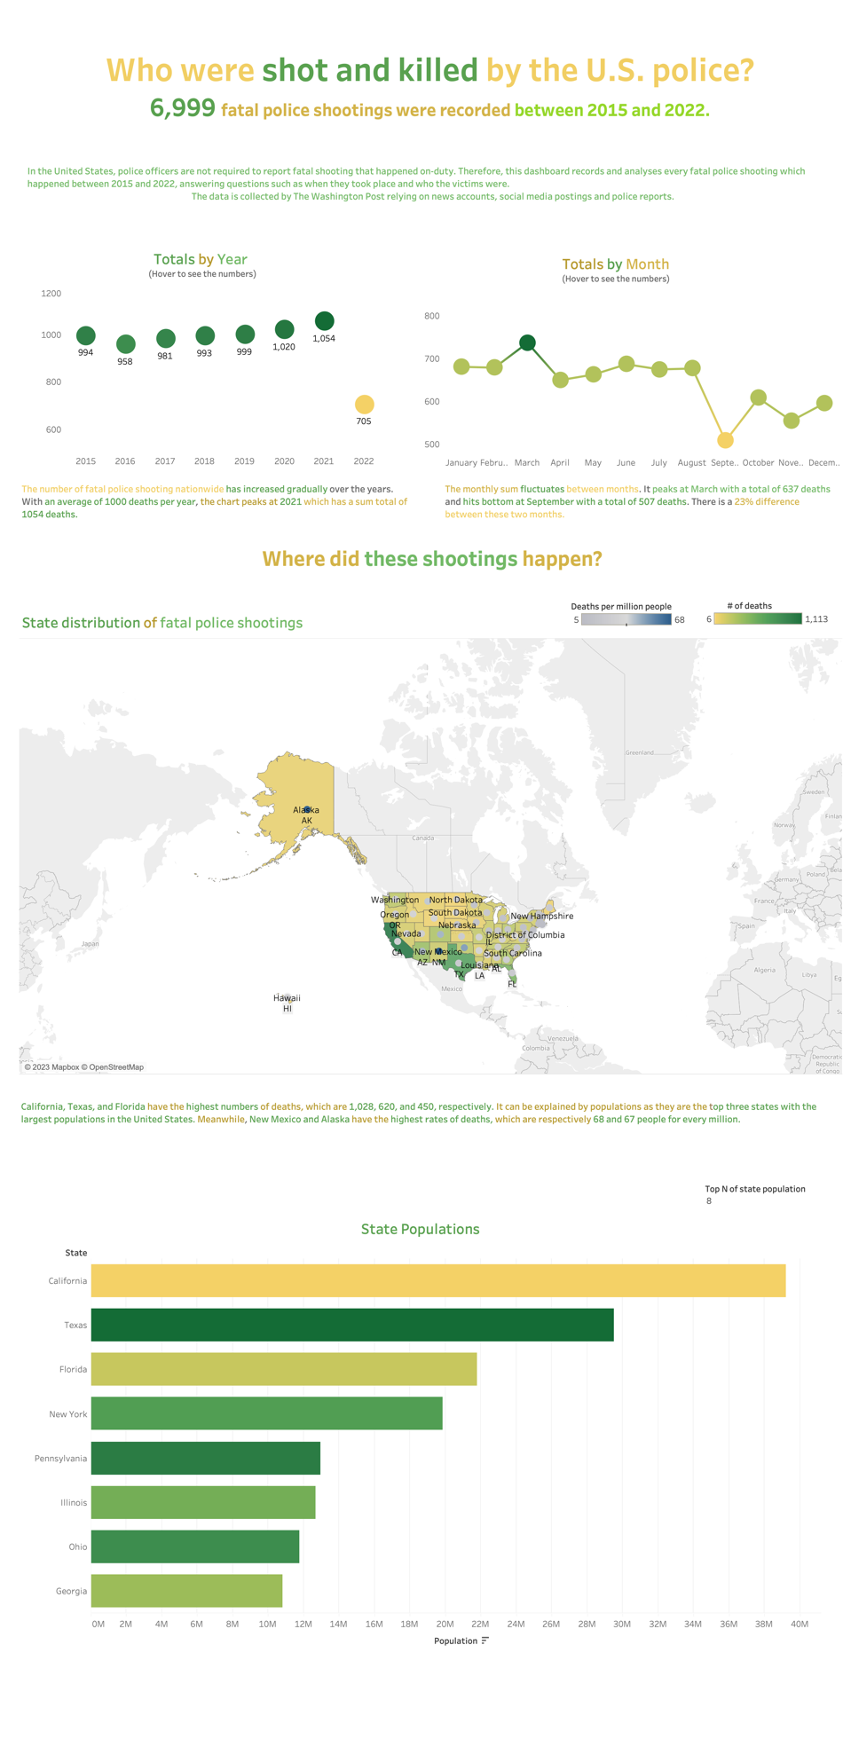 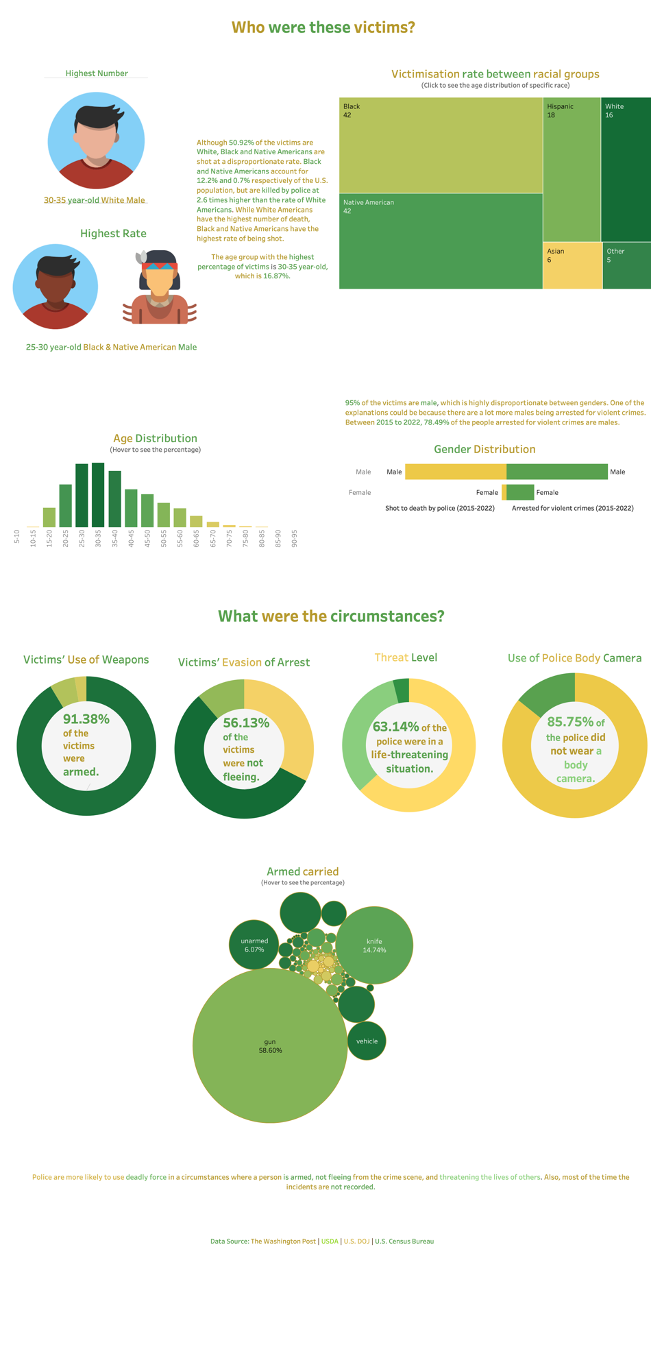

**Visualizations :**

1. I used different types of visualization to analyze the data.
2. I have used a parameter that shows Top N state populations.
3. Used the Diverging Bar Chart for Gender Distribution.
4. I have created a calculated field for Donut.
5. I have used these icons by downloading a particular image from Google and saving it in Documents - My Tableau Repository, and in that Shapes folder, I have pasted these icons, and used individual icons from the Shape tab in the Tableau workbook.

**My further research questions would be:**

1. How do police shooting rates differ between urban, suburban, and rural areas?

2. What is the impact of police training programs on the use of force and the rate of police shootings?

3. What are the media's framing and coverage of police shootings, and how does this impact public understanding of these events?

**Conclusion**

In conclusion, fatal police shootings in the United States remain a complex and deeply troubling issue that demands urgent attention and systemic reform. The loss of life, often accompanied by questions of excessive force, racial bias, and inadequate training, underscores the need for comprehensive changes within law enforcement agencies. Smashing a proportion between securing public safety and protecting individual rights is crucial for rebuilding trust between communities and the police.

Managing this issue requires a multi-faceted technique, including enhanced police training in de-escalation techniques, increased transparency through body cameras, and rigorous accountability for officers violating established protocols. Furthermore, fostering community engagement and promoting dialogue between law enforcement and the public can contribute to a more harmonious relationship, promoting mutual understanding and reducing the likelihood of tragic outcomes.

Ultimately, policymakers, law enforcement agencies, and communities must collaborate in developing and implementing reforms that prioritize preserving life, upholding justice, and promoting equality under the law. By acknowledging the gravity of the situation and working together to effect meaningful change, we can aspire to a future where fatal police shootings are rare occurrences, and the principles of justice and accountability are supported for the benefit of all.